VES-WCCBM

SY IT SEM IV SOFTWARE ENGINEERING PRACTICAL-4

Purpose of Activity Diagrams

The basic purposes of activity diagrams is similar to other four diagrams. It captures the dynamic behavior of the system. Other four diagrams are used to show the message flow from one object to another but activity diagram is used to show message flow from one activity to another.

Activity is a particular operation of the system. Activity diagrams are not only used for visualizing the dynamic nature of a system, but they are also used to construct the executable system by using forward and reverse engineering techniques. The only missing thing in the activity diagram is the message part.

It does not show any message flow from one activity to another. Activity diagram is sometimes considered as the flowchart. Although the diagrams look like a flowchart, they are not. It shows different flows such as parallel, branched, concurrent, and single.

The purpose of an activity diagram can be described as −

* Draw the activity flow of a system.
* Describe the sequence from one activity to another.
* Describe the parallel, branched and concurrent flow of the system.

How to Draw an Activity Diagram?

Activity diagrams are mainly used as a flowchart that consists of activities performed by the system. Activity diagrams are not exactly flowcharts as they have some additional capabilities. These additional capabilities include branching, parallel flow, swimlane, etc.

Before drawing an activity diagram, we must have a clear understanding about the elements used in activity diagram. The main element of an activity diagram is the activity itself. An activity is a function performed by the system. After identifying the activities, we need to understand how they are associated with constraints and conditions.

Before drawing an activity diagram, we should identify the following elements −

* Activities
* Association
* Conditions
* Constraints

Once the above-mentioned parameters are identified, we need to make a mental layout of the entire flow. This mental layout is then transformed into an activity diagram.

Following is an example of an activity diagram for order management system. In the diagram, four activities are identified which are associated with conditions. One important point should be clearly understood that an activity diagram cannot be exactly matched with the code. The activity diagram is made to understand the flow of activities and is mainly used by the business users

Following diagram is drawn with the four main activities −

* Send order by the customer
* Receipt of the order
* Confirm the order
* Dispatch the order

After receiving the order request, condition checks are performed to check if it is normal or special order. After the type of order is identified, dispatch activity is performed and that is marked as the termination of the process.

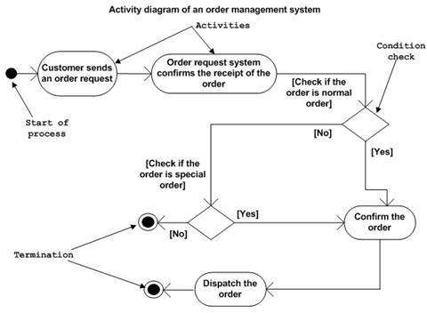

Where to Use Activity Diagrams?

The basic usage of activity diagram is similar to other four UML diagrams. The specific usage is to model the control flow from one activity to another. This control flow does not include messages.

Activity diagram is suitable for modeling the activity flow of the system. An application can have multiple systems. Activity diagram also captures these systems and describes the flow from one system to another. This specific usage is not available in other diagrams. These systems can be database, external queues, or any other system.

We will now look into the practical applications of the activity diagram. From the above discussion, it is clear that an activity diagram is drawn from a very high level. So it gives high level view of a system. This high level view is mainly for business users or any other person who is not a technical person.

This diagram is used to model the activities which are nothing but business requirements. The diagram has more impact on business understanding rather than on implementation details.